Basera Shaik 21BCE7907

basanthi.21bce7907@vitapstudent.ac.in CAMPUS: VIT-AP

# 1. IMPORT THE LIBRARIES

|  |
| --- |
| import numpy as np import pandas as pd  import matplotlib.pyplot as plt import seaborn as sns from scipy import stats  from sklearn.preprocessing import LabelEncoder from sklearn.preprocessing import StandardScaler from sklearn.model_selection import train_test_split |

# 2. IMPORT THE DATASET

|  |  |  |  |  |  |  |  |  |  |  |  |  |  |  |  |  |  |  |  |  |  |  |  |  |  |  |  |  |  |  |  |  |  |  |  |  |  |  |  |  |  |  |  |  |
| --- | --- | --- | --- | --- | --- | --- | --- | --- | --- | --- | --- | --- | --- | --- | --- | --- | --- | --- | --- | --- | --- | --- | --- | --- | --- | --- | --- | --- | --- | --- | --- | --- | --- | --- | --- | --- | --- | --- | --- | --- | --- | --- | --- | --- |
| df=pd.read_csv("Titanic-Dataset.csv") df   |  |  | | --- | --- | | PassengerId Survived Pclass \ | | | 0 1 0 | 3 | | 1 2 1 | 1 | | 2 3 1 | 3 | | 3 4 1 | 1 | | 4 5 0 | .  3  2 | | .. ... ... .. | | 886 887 0 | | 887 888 1 | 1 | | 888 889 0 | 3 | | 889 890 1 | 1 | | 890 891 0 | 3 |  |  |  | | --- | --- | | Name Sex Age | | | SibSp \ |  | | Braund, Mr. Owen Harris male 22.0 | | |  | | | Cumings, Mrs. John Bradley (Florence Briggs Th... female 38.0 | | |  | | | Heikkinen, Miss. Laina female 26.0 | | |  | | | Futrelle, Mrs. Jacques Heath (Lily May Peel) female 35.0 | | |  | | | Allen, Mr. William Henry male 35.0 | |   0  1  1  1  2  0  3  1  4 |

|  |  |  |  |  |  |  |  |  |  |  |  |  |  |  |  |  |  |  |  |  |  |  |  |  |  |  |  |  |  |  |  |  |  |  |  |  |  |  |  |  |  |  |  |  |  |  |  |  |  |  |  |  |  |  |  |  |  |  |  |  |  |  |  |  |  |
| --- | --- | --- | --- | --- | --- | --- | --- | --- | --- | --- | --- | --- | --- | --- | --- | --- | --- | --- | --- | --- | --- | --- | --- | --- | --- | --- | --- | --- | --- | --- | --- | --- | --- | --- | --- | --- | --- | --- | --- | --- | --- | --- | --- | --- | --- | --- | --- | --- | --- | --- | --- | --- | --- | --- | --- | --- | --- | --- | --- | --- | --- | --- | --- | --- | --- |
| |  |  | | --- | --- | |  | | | .. ... ... ... | | | .. | . | | 886 Montvila, Rev. Juozas male 27.0 | | |  | | | 887 Graham, Miss. Margaret Edith female 19.0 | | |  | | | 888 Johnston, Miss. Catherine Helen "Carrie" female NaN | | |  | | | 889 Behr, Mr. Karl Howell male 26.0 | | |  | | | 890 Dooley, Mr. Patrick male 32.0 | | |  | |   0  0  0  1  0 0   |  |  | | --- | --- | | Parch Ticket Fare Cabin Embarked | | | 1. 0 A/5 21171 7.2500 NaN S 2. 0 PC 17599 71.2833 C85 C 2 0 STON/O2. 3101282 7.9250 NaN S 3 0 113803 53.1000 C123 S   4 0 373450 8.0500 NaN S .. ... ... ... ... ... 886 0 211536 13.0000 NaN S   1. 0 112053 30.0000 B42 S 2. 2 W./C. 6607 23.4500 NaN S 3. 0 111369 30.0000 C148 C 4. 0 370376 7.7500 NaN Q | | | [891 rows x 12 columns] |   df.head()   |  |  | | --- | --- | | PassengerId Survived Pclass \ | | | 0 1 0 | 3 | | 1 2 1 | 1 | | 2 3 1 | 3 | | 3 4 1 | 1 | | 4 5 0 | 3 |  |  |  | | --- | --- | | Name Sex Age | | | SibSp \ |  | | Braund, Mr. Owen Harris male 22.0 | | |  | | | Cumings, Mrs. John Bradley (Florence Briggs Th... female 38.0 | | |  | | | Heikkinen, Miss. Laina female 26.0 | | |  | | | Futrelle, Mrs. Jacques Heath (Lily May Peel) female 35.0 | | |  | | | Allen, Mr. William Henry male 35.0 | |   0  1  1  1  2  0  3  1  4 |

0

Parch Ticket Fare Cabin Embarked 0 0 A/5 21171 7.2500 NaN S

1. 0 PC 17599 71.2833 C85 C
2. 0 STON/O2. 3101282 7.9250 NaN S
3. 0 113803 53.1000 C123 S 4 0 373450 8.0500 NaN S df.tail()

PassengerId Survived Pclass

Name \

1. 887 0 2 Montvila, Rev.

Juozas

1. 888 1 1 Graham, Miss. Margaret Edith
2. 889 0 3 Johnston, Miss. Catherine Helen

"Carrie"

1. 890 1 1 Behr, Mr. Karl

Howell

1. 891 0 3 Dooley, Mr.

Patrick

Sex Age SibSp Parch Ticket Fare Cabin Embarked 886 male 27.0 0 0 211536 13.00 NaN S 887 female 19.0 0 0 112053 30.00 B42 S 888 female NaN 1 2 W./C. 6607 23.45 NaN S

889 male 26.0 0 0 111369 30.00 C148 C 890 male 32.0 0 0 370376 7.75 NaN Q df.shape (891, 12) df.info()

<class 'pandas.core.frame.DataFrame'> RangeIndex: 891 entries, 0 to 890

Data columns (total 12 columns):

# Column Non-Null Count Dtype --- ------ -------------- ----- 0 PassengerId 891 non-null int64 1 Survived 891 non-null int64 2 Pclass 891 non-null int64 3 Name 891 non-null object

4 Sex 891 non-null object 5 Age 714 non-null float64 6 SibSp 891 non-null int64

7 Parch 891 non-null int64 8 Ticket 891 non-null object 9 Fare 891 non-null float64 10 Cabin 204 non-null object 11 Embarked 889 non-null object dtypes: float64(2), int64(5), object(5) memory usage: 83.7+ KB df.describe()

PassengerId Survived Pclass Age SibSp \ count 891.000000 891.000000 891.000000 714.000000 891.000000 mean 446.000000 0.383838 2.308642 29.699118 0.523008 std 257.353842 0.486592 0.836071 14.526497 1.102743 min 1.000000 0.000000 1.000000 0.420000 0.000000 25% 223.500000 0.000000 2.000000 20.125000 0.000000

50% 446.000000 0.000000 3.000000 28.000000 0.000000 75% 668.500000 1.000000 3.000000 38.000000 1.000000 max 891.000000 1.000000 3.000000 80.000000 8.000000

Parch Fare count 891.000000 891.000000 mean 0.381594 32.204208 std 0.806057 49.693429 min 0.000000 0.000000 25% 0.000000 7.910400

50% 0.000000 14.454200 75% 0.000000 31.000000 max 6.000000 512.329200

corr=df.corr() corr

<ipython-input-13-7d5195e2bf4d>:1: FutureWarning: The default value of numeric_only in DataFrame.corr is deprecated. In a future version, it will default to False. Select only valid columns or specify the value of numeric_only to silence this warning. corr=df.corr()

PassengerId Survived Pclass Age SibSp Parch \

PassengerId 1.000000 -0.005007 -0.035144 0.036847 -0.057527 -

0.001652

Survived -0.005007 1.000000 -0.338481 -0.077221 -0.035322

0.081629

Pclass -0.035144 -0.338481 1.000000 -0.369226 0.083081

0.018443

Age 0.036847 -0.077221 -0.369226 1.000000 -0.308247 -

0.189119

SibSp -0.057527 -0.035322 0.083081 -0.308247 1.000000

0.414838

Parch -0.001652 0.081629 0.018443 -0.189119 0.414838

|  |  |  |
| --- | --- | --- |
| 1.000000  Fare 0.012658 0.257307 -0.549500 0.096067 0.159651  0.216225   |  | | --- | | Fare | | PassengerId 0.012658  Survived 0.257307 Pclass -0.549500  Age 0.096067  SibSp 0.159651  Parch 0.216225  Fare 1.000000 |   plt.subplots(figsize=(15,10)) sns.heatmap(corr,annot=True)  <Axes: > |

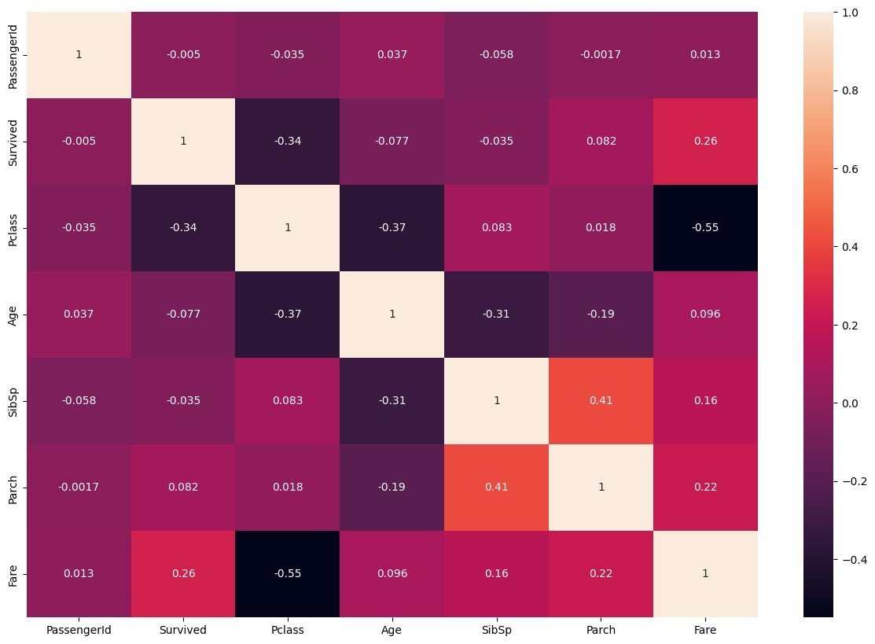

df.Survived.value_counts()

|  |  |  |  |  |  |  |  |  |  |  |  |  |
| --- | --- | --- | --- | --- | --- | --- | --- | --- | --- | --- | --- | --- |
| |  |  | | --- | --- | | 1. 549 2. 342 |  | | Name: Survived, dtype: int64 | |   df.Sex.value_counts()   |  |  | | --- | --- | | male 577 female 314 |  | | Name: Sex, dtype: int64 | |   df.Embarked.value_counts()   |  |  | | --- | --- | | S 644  C 168  Q 77 |  | | Name: Embarked, dtype: int64 | | |

#3. CHECK FOR NULL VALUES

|  |  |  |  |  |  |  |  |  |  |  |  |  |  |  |  |  |
| --- | --- | --- | --- | --- | --- | --- | --- | --- | --- | --- | --- | --- | --- | --- | --- | --- |
| df.isnull().any()   |  |  | | --- | --- | | PassengerId False  Survived False Pclass False  Name False  Sex False  Age True  SibSp False  Parch False  Ticket False  Fare False  Cabin True Embarked True | | | dtype: bool |  |   df.isnull().sum()   |  |  | | --- | --- | | PassengerId 0  Survived 0 Pclass 0  Name 0  Sex 0 | | | Age 177 | | | SibSp 0  Parch 0  Ticket 0  Fare 0 | | | Cabin 687 | | | Embarked 2 | | | dtype: int64 |  | |

Fill null values in the 'Age' column with the mean age

mean_age = df['Age'].mean() df['Age'].fillna(mean_age, inplace=True)

Fill null values in the 'Embarked' column with the most common value

|  |  |  |  |  |
| --- | --- | --- | --- | --- |
| most_common_embarked = df['Embarked'].mode()[0] df['Embarked'].fillna(most_common_embarked, inplace=True) df.drop(['Cabin'],axis=1, inplace=True) df.drop(['Ticket'],axis=1, inplace=True) df.drop(['Name'],axis=1,inplace=True) print(df.isnull().sum())   |  |  | | --- | --- | | PassengerId 0  Survived 0 Pclass 0  Sex 0  Age 0  SibSp 0  Parch 0  Fare 0 Embarked 0 | | | dtype: int64 |  | |

#4. Data Visualization

|  |
| --- |
| *# Visualize the distribution of the 'Survived' column (0 = Not Survived, 1 = Survived)*  sns.countplot(data=df, x='Survived') plt.title('Survival Count') plt.xlabel('Survived') plt.ylabel('Count') plt.show() |

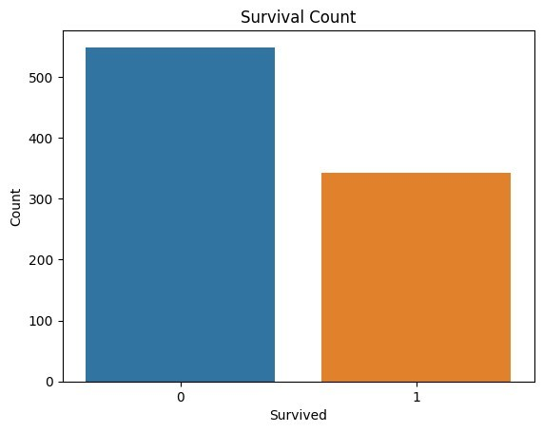

*#Visualize the distribution of the 'Age' column* sns.histplot(data=df, x='Age', bins=20, kde=True) plt.title('Age Distribution') plt.xlabel('Age') plt.ylabel('Count') plt.show()

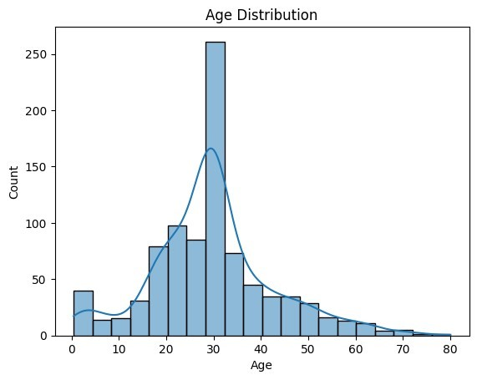

*#Visualize the distribution of the 'Fare' column and detect outliers we will handle outliers in the next step* sns.boxplot(data=df, x='Fare') plt.title('Fare Distribution') plt.xlabel('Fare') plt.show()

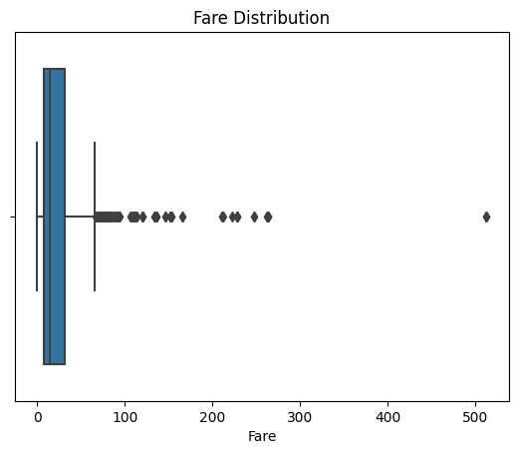

*#Pair plot for selected numerical columns* sns.pairplot(data=df[['Fare', 'SibSp', 'Parch']]) plt.title('Pair Plot') plt.show()

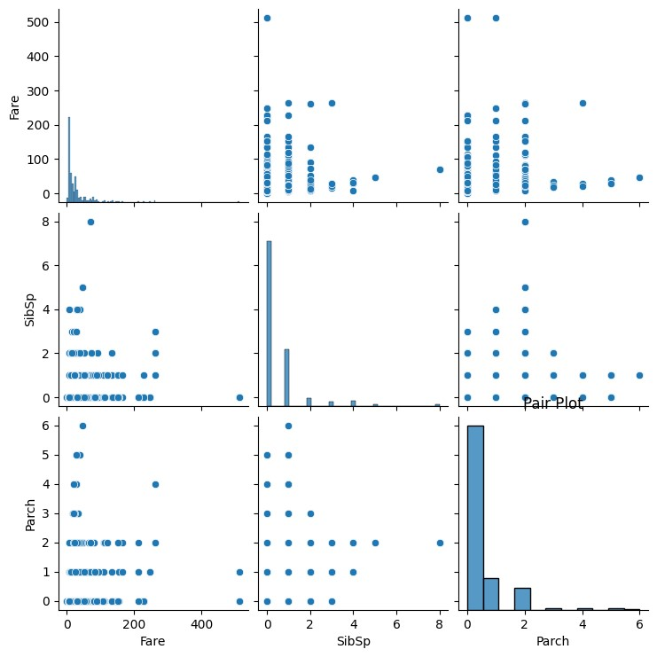

corr_matrix

=

df.corr()

sns.heatmap(corr_matrix, annot

=

True

,cmap

=

'coolwarm'

)

plt.title(

'Correlation Heatmap'

)

plt.show()

ipython-input-30-8dcbd071fff3>:1: FutureWarning: The default value of

<

numeric_only in DataFrame.corr is deprecated. In a future version, it

will default to False. Select only valid columns or specify the value

of numeric_only to silence this warning.

corr_matrix = df.corr(

)

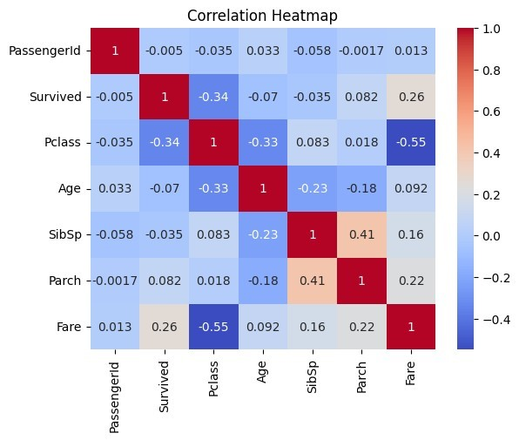

# 5. Detect and Handle Outliers

|  |  |  |  |  |
| --- | --- | --- | --- | --- |
| z_scores = np.abs(stats.zscore(df['Age'])) max_threshold=3  outliers = df['Age'][z_scores > max_threshold]  *# Print and visualize the outliers* print("Outliers detected using Z-Score:") print(outliers)   |  |  | | --- | --- | | Outliers detected using Z-Score: | | | 96 71.0  116 70.5 |  |   493  71.0    630  80.0    672  70.0    745  70.0    851  74.0    Name: Age, dtype: float6  4 |

|  |  |  |  |  |  |  |  |  |  |
| --- | --- | --- | --- | --- | --- | --- | --- | --- | --- |
| z_scores = np.abs(stats.zscore(df['Fare'])) max_threshold=3  outliers = df['Fare'][z_scores > max_threshold]  *# Print and visualize the outliers* print("Outliers detected using Z-Score:") print(outliers)   |  |  |  | | --- | --- | --- | | Outliers detected using Z-Score: | | | | 27 263.0000  88 263.0000  118 247.5208  258 512.3292  299 247.5208  311 262.3750  341 263.0000  377 211.5000  380 227.5250  438 263.0000  527 221.7792  557 227.5250  679 512.3292  689 211.3375  700 227.5250  716 227.5250  730 211.3375  737 512.3292  742 262.3750  779 211.3375 |  | | | Name: Fare, dtype: float64 | |  |   column_name = 'Fare'  *# Calculate the first quartile (Q1) and third quartile (Q3)*  Q1 = df[column_name].quantile(0.25)  Q3 = df[column_name].quantile(0.75)  *# Calculate the IQR*  IQR = Q3 - Q1  *# Define the lower and upper bounds for outliers* lower_bound = Q1 - 1.5 * IQR upper_bound = Q3 + 1.5 * IQR  *# Filter rows with values outside the IQR bounds*  df_cleaned = df[(df[column_name] > lower_bound) & (df[column_name] <upper_bound)]  *# Display the original and cleaned DataFrame sizes* print(f"Original DataFrame size: {df.shape}") |

print(f"Cleaned DataFrame size: {df_cleaned.shape}") df_cleaned

Original DataFrame size: (891, 9)

Cleaned DataFrame size: (775, 9)

PassengerId Survived Pclass Sex Age SibSp Parch

Fare \

0 1 0 3 male 22.000000 1 0

7.2500

1. 3 1 3 female 26.000000 0 0 7.9250
2. 4 1 1 female 35.000000 1 0 53.1000
3. 5 0 3 male 35.000000 0 0

8.0500

1. 6 0 3 male 29.699118 0 0

8.4583

.. ... ... ... ... ... ... ...

...

1. 887 0 2 male 27.000000 0 0

13.0000

1. 888 1 1 female 19.000000 0 0

30.0000

1. 889 0 3 female 29.699118 1 2

23.4500

1. 890 1 1 male 26.000000 0 0 30.0000
2. 891 0 3 male 32.000000 0 0

7.7500

Embarked 0 S

1. S
2. S
3. S
4. Q .. ...
5. S
6. S
7. S
8. C
9. Q

[775 rows x 9 columns] sns.boxplot(df_cleaned)

<Axes: >

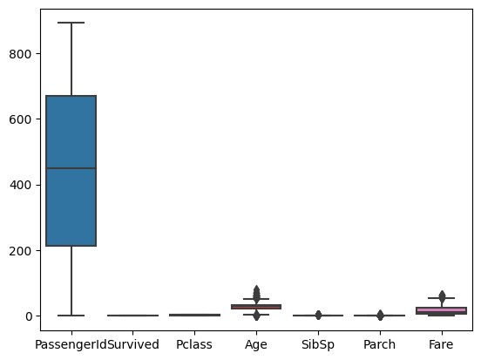

|  |  |  |  |  |  |  |  |  |  |  |  |  |  |  |  |  |  |  |  |  |  |  |  |  |  |
| --- | --- | --- | --- | --- | --- | --- | --- | --- | --- | --- | --- | --- | --- | --- | --- | --- | --- | --- | --- | --- | --- | --- | --- | --- | --- |
| df=df_cleaned  x=df.drop('Survived', axis=1) y=df['Survived'] x.head()   |  |  | | --- | --- | | PassengerId Pclass Sex Age SibSp Parch Fare | | | Embarked |  | | 1 3 male 22.000000 1 0 7.2500 | | |  | | | 3 3 female 26.000000 0 0 7.9250 | | |  | | | 4 1 female 35.000000 1 0 53.1000 | | |  | | | 5 3 male 35.000000 0 0 8.0500 | | |  | | | 6 3 male 29.699118 0 0 8.4583 | | |  | |   0  S  2  S  3  S  4  S  5 Q  y.head()   |  | | --- | | 0 0   1. 1 2. 1 3. 0 | |
| |  |  | | --- | --- | | 5 0 |  | | Name: Survived, dtype: int64 | | |

#7. Perform Encoding

|  |  |  |  |  |  |  |  |  |  |  |  |  |  |  |  |  |  |  |  |  |  |  |  |  |  |  |  |  |
| --- | --- | --- | --- | --- | --- | --- | --- | --- | --- | --- | --- | --- | --- | --- | --- | --- | --- | --- | --- | --- | --- | --- | --- | --- | --- | --- | --- | --- |
| en = LabelEncoder()  x['Sex'] = en.fit_transform(x['Sex']) x.head()   |  | | --- | | PassengerId Pclass Sex Age SibSp Parch Fare Embarked | | 0 1 3 1 22.000000 1 0 7.2500 S   1. 3 3 0 26.000000 0 0 7.9250 S 2. 4 1 0 35.000000 1 0 53.1000 S 3. 5 3 1 35.000000 0 0 8.0500 S 4. 6 3 1 29.699118 0 0 8.4583 Q |   x = pd.get_dummies(x,columns=['Embarked']) x.head()   |  |  | | --- | --- | | PassengerId Pclass Sex Age SibSp Parch Fare | | | Embarked_C \ |  | | 1 3 1 22.000000 1 0 7.2500 | | |  | | | 3 3 0 26.000000 0 0 7.9250 | | |  | | | 4 1 0 35.000000 1 0 53.1000 | | |  | | | 5 3 1 35.000000 0 0 8.0500 | | |  | | | 6 3 1 29.699118 0 0 8.4583 | | |  | |   0  0  2  0  3  0  4  0  5  0   |  | | --- | | Embarked_Q Embarked_S | | 0 0 1   1. 0 1 2. 0 1 3. 0 1 4. 1 0 | |

#8. Feature Scaling

|  |  |  |  |  |
| --- | --- | --- | --- | --- |
| scale = StandardScaler()  x[['Age', 'Fare']] = scale.fit_transform(x[['Age', 'Fare']]) x.head()   |  |  | | --- | --- | | PassengerId Pclass Sex Age SibSp Parch Fare | | | Embarked_C \ |  | |

0 1 3 1 -0.556219 1 0 -0.779117

0

1. 3 3 0 -0.243027 0 0 -0.729373

0

1. 4 1 0 0.461654 1 0 2.599828

0

1. 5 3 1 0.461654 0 0 -0.720161

0

1. 6 3 1 0.046606 0 0 -0.690071 0

Embarked_Q Embarked_S

0 0 1

1. 0 1
2. 0 1
3. 0 1
4. 1 0

#9. Splitting the data into Train and Test

|  |  |  |  |  |
| --- | --- | --- | --- | --- |
| x_train, x_test, y_train, y_test = train_test_split(x, y, test_size=0.2, random_state=42)  print(x_train.shape) print(x_test.shape) print(y_train.shape) print(y_test.shape)   |  |  | | --- | --- | | (620, 10)  (155, 10) | | | (620,)  (155,) |  | |